Updating the Official Website of the Ministry

This has reference to your letter No. MWCA/05/07/04 dated 06.02.2025 on the above matter. The programs implemented by the National Committee on Women according to its action plan are as follows.

- Raising awareness at the ministry and district levels (key officials) about the 1938 Women's Helpline Service and gender equality and gender based-violence
- Develop sensitivity among police officers and implement programs to build cooperation between ministry officials and police officers based on the nature of the complaints received by the 1938 Women's Helpline and the Complaints Center.
- Raising Awareness about cybercrime in sign language for those in selected Centers for the Deaf and Dumb.
- Implementing awareness programs in private sector (investment zones and other private companies/garments) institutions on the 1938 Women's Helpline Service, reproductive health, prevention of sexually transmitted diseases/HIV, violence against women in the workplace and the prevention of domestic violence.
- Implementing awareness programs on the Prevention of Gender-Based Violence and Domestic Violence Act for the officers employed in the public sector.
- Implementing awareness programs in line with the International 16 Day Programme for the Elimination of All Forms of Violence against Women and Girls.
- Improving knowledge about the prevention of violence against women and children and the related laws
- Awareness programmes on cyber violence and harassment in public transport for students in higher education institutions - 2024
- Implementing programs on the pre-marital counseling to marriage intended young community
- Implementing two-day leadership training workshops to empower women in politics. -2024
- Implementing awareness programs on the prevention of sexual and gender-based cyber violence for all officers of the Women and Child Development Units attached to the District Secretariats and Divisional Secretariats, in line with the International Women's Day
- Implementing two-day residential training programs on stress management and skill development for officers involved in the 1938 Women's Helpline Service of the National Committee on Women and other officers implementing SAARC projects.
- Implementing mobile service programs and health clinic programs to provide relief to low-income women.

- Raising awareness at the ministry and district levels (key officials) about the 1938 Women's Helpline Service and gender equality and gender based-violence

With violence against women and children on the rise in Sri Lanka and globally, it is crucial to improve awareness among public officials, especially those involved in policy making and service delivery. The National Committee on Women initiated a training programme for officers at all levels i.e. national, provincial, district and divisional, on gender-based violence, helpline services of 1938 and 1929 for women and children and victim support networks. This programme has already been implemented in Kandy.

- Develop sensitivity among police officers and implement programs to build cooperation between ministry officials and police officers based on the nature of the complaints received by the 1938 Women's Helpline and the Complaints Center

The 1938 Women's Helpline Service coordinates with police stations regarding violence against women. Gender sensitivity and proper training in legal procedures is essential for police officers to handle complaints efficiently and support victims. To enhance that collaboration, training sessions were held for Officers-in-Charge of the Police Stations, officers involved in the prevention of child and women abuse, and support service staff:

On 29 March 2024 - in Galle District
On 09 October 2024 - in Kegalle District
These programs aim to strengthen institutional coordination and improve service delivery for victims.

- Raising Awareness about cybercrime in sign language for those in selected Centers for the Deaf and Dumb
It is common today for all women and girls in society becoming victims of cyberspace violence while interacting with modern technology. Meanwhile, as a special group of people in society, people with hearing and speech impairments, face many problems in using smart phones for communication. Based on the information obtained from the Department of Social Services in this regard, it is expected to implement training programs in several selected districts to educate people with hearing and speech impairments on how to minimize possible violence through cyberspace.
Therefore, the National Committee on Women has decided to implement these awareness programs for people with hearing and speech impairments in the districts of Kalutara, Galle, Kandy, Anuradhapura and Monaragala with the primary aim of raising awareness about possible violence through cyberspace and preventive action to be taken.

- Implementing awareness programs in private sector (investment zones and other private companies/garments) institutions on the 1938 Women's Helpline Service, reproductive health, prevention of sexually transmitted diseases/HIV, violence against women in the workplace and the prevention of domestic violence.
Women and children are disadvantaged due to factors such as being victims of violence, gender issues, and lack of knowledge about reproductive health, and acts of violence and deprivation of rights against them have increased rapidly in Sri Lanka and around the world. Accordingly, one of the main objectives of this project is to make the community aware of the 1938 and 1929 Women and Child Helpline Services and promote the same with interventions at the ministry level and to provide knowledge on the relevant subject areas. Under this, it is expected to educate employees in the private sector, including employees in free trade zones, employees and workers in garment and other factories (in house/outdoor), employees and workers in estates, etc. through these projects. This program has been implemented in Trincomalee and Anuradhapura districts.

- Awareness programme on Prevention of Gender Based Violence and Domestic Violence Act for officers in workplaces of Government Sector

The purpose of implementing these programs was to educate the community about the Prevention of Domestic Violence Act, minimize violence against women in the workplace, create a peaceful environment within the family by minimizing domestic violence, and thereby increase the job productivity of the officer.
Programs were implemented under the following topics:
- Introducing the concept of gender

- Awareness of the Prevention of Domestic Violence Act

- Counselling program to create a peaceful environment within the family
The first program was successfully held on 17.05.2024 and the second program on 27.11.2024 at the auditorium on 6th floor of Sethsiripaya-Stage II.
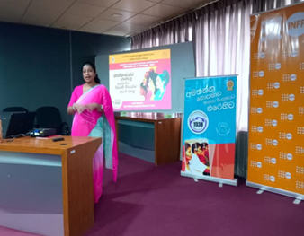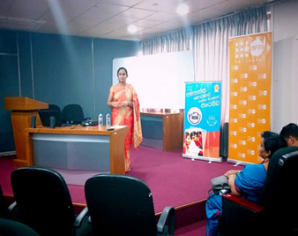
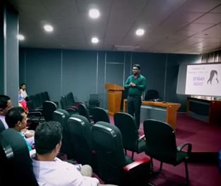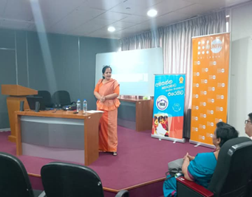
- Implementing awareness programs in conjunction with the International 16 Day Program for the Prevention of all forms of Violence against Women and girls

The inaugural ceremony, coinciding with the International 16 Day Program for the Elimination of Violence against Women, was held on 25.11.2024 at the auditorium on 11th floor of Sethsiripaya-Stage II from 9.30 a.m. to 1.30 p.m. with financial support from the United Nations Population Fund (UNFPA).
Sixteen (16) days have been designated internationally to eliminate all forms of violence against women and girls. These international days begin on 25 November and end on 10 December, International Human Rights Day.
This program was held under the patronage of the Hon. Minister of Women and Child Affairs and it conveyed a message about prevention of violence through the entertaining performances of ministry officials.
More than 230 officials from the Women and Child Development Units of all Divisional Secretariats in the Colombo District, as well as officials from ministries and departments located at the Sethsiripaya Stage II premises, participated in this program.
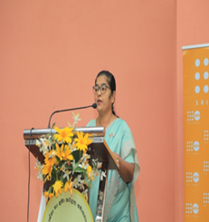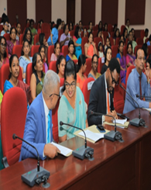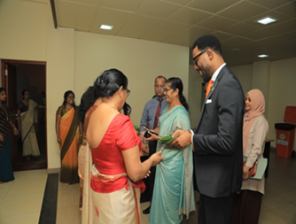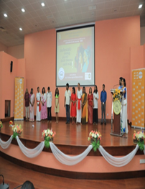
- Improving knowledge about the prevention of violence against women and children and the related laws
The National Committee on Women of the Ministry of Women and Child Affairs has organized a series of awareness programs for officials of government institutions/export processing zones/workplaces that directly interact with the public and for the management and employees of other private institutions.
The program is being implemented as a professional support that can be provided to employees to resolve personal and work-related issues that affect their well-being and performance. This provides an opportunity for all staff in the workplace to talk about their problems and seek guidance from professionals in those fields. This awareness campaign expects to address the emotional issues faced by employees, such as stress, anxiety, and depression, as well as a host of other issues they face in their daily lives, such as ignorance of the general law. The importance of mental health in the workplace has become a concept that is receiving increasing attention around the world. Creating a healthy work environment for both employees and employers can lead to job satisfaction and organizational success, as well as development in their personal lives.
This program has already been implemented at Ruhunu Foods (Pvt) Ltd in Kundasale, Linea Clothing, Eskimo Fashion Knitwear (Private) Limited in the Kandy District, Sri Lanka Board of Investment in Gampaha and Avissawella, Akmeemana Divisional Secretariat in Galle, and PGP Glass Ceylon PLC in the Horana Wagawatte Industrial Zone.

- Awareness programmes on cyber violence and harassment in public transport for students in higher education institutions -2024
Nowadays it is commonplace to see children in romantic relationships and unprotected sexual relationships due to the freedom in higher education institutions and children addicted to mobile phones and the Internet, becoming victims of cyber crimes and facing various physical, mental and sexual harassments while using public transport services. It is evident that most of the problems faced by young people that reported to the 1938- Women’s Help Line and the Complaints Center of the national Committee on Women are related to these problems.
Accordingly, awareness programs were implemented at the Ginihappitiya Vocational Training Center in the Mawanella Divisional Secretariat Division, Vocational Training Center in the Sri Jayewardenepura Divisional Secretariat, Technical Collage in Godagama-Homagama, National Youth Services Council in Kalutara-Panadura, Technical College in Kegalle, Vocational Training Authority in Aranayake, Bandarawela Divisional Secretariat, Technical College in Badulla, Vocational Training Centre in Amunukumbura-Gampaha and the Jaffna District Secretariat as per the instructions of the National Committee on Women.

- Implementation of premarital counseling programs for marriage intended young community
It is very important to minimize and raise awareness about the various problems faced by the youth community as they grow up, based on gender in Sri Lanka today. Among them, the factors that cause domestic violence are the gender inequality in the family, sexuality, and violence between husband and wife. This program which is implemented by the National Committee on Women, provided guidance on solutions to the issues that arise during adolescence through premarital counseling and raised awareness about the legal background related to marriage. This program targeted youth communities in the Matale, Trincomalee, Polonnaruwa, Kelaniya Divisional Secretariat Divisions and Gampaha Divisional Secretariat Division. Accordingly, the program was successfully implemented by raising awareness of the legal background and reproductive health related to marriage among young people who are planning to get married.

- Two-Day Leadership Training Workshop on Empowering Women for Politics – 2024
The low level of participation of women in politics is a matter of constant discussion in society. Currently, women's representation in parliament is 5.8%, in provincial councils 3.9%, and in local government bodies 1.9%. Despite the fact that women represent 52% of the total population in Sri Lanka, the low level of participation of women in politics has raised issues of women's rights and discrimination against women. Women's organizations are raising a strong voice in society to change this situation. It was observed in the last local government election that a group of honest, active women who were committed to public service and identified with the needs of the people in the village enter politics, rather than women from families with a purely political background. Therefore, in accordance with the annual plan for 2023 of the National Committee on Women, a series of two-day leadership training workshops to empower women in politics were held in all twenty-five districts. The objective of providing this training program for officers in all District Women Federations registered with our Ministry is to prepare the necessary background for women to enter politics and to promote the importance of women in political councils, political systems, and communication skills regarding leadership. Programs have already been implemented in the districts of Mannar, Galle, Trincomalee, Badulla, Anuradhapura, Jaffna, Kandy, Ratnapura, Vavuniya, Kurunegala, Colombo and Matale.

- Implementing awareness programs on the prevention of sexual and gender-based cyber violence for all officers of the Women and Child Development Units attached to the District Secretariats and Divisional Secretariats, in line with the International Women's Day.
This year, as every year, our Ministry has planned to implement a number of programs to mark the National Women's Day celebration. According to a data analysis conducted by the National Committee on Women, considering the total number of complaints received by the 1938 Women's Helpline Service in the year 2023, the main reason for the complaints received by the 1938 Women's Helpline Service of the National Committee on Women is violence against women and children due to cybercrime. Five districts that received the highest number of complaints were selected according to their population percentage and arrangements were made to implement five programs to train as trainers for officers of the Women and Child Development Units attached to those district secretariats on the topic of preventing sexual and gender-based cyber violence. This program was held in the districts of Polonnaruwa, Kandy, Ampara, Monaragala and Trincomalee for the year 2024 on the said topics.
- Implementing two-day residential training programs on stress management and skill development for officers involved in the 1938 Women's Helpline Service of the National Committee on Women and other officers implementing SAARC projects.
It was decided to implement a two-day residential training program on skill development for officers involved in the 1938 Women's Helpline Service of National Committee on Women and other officers implementing the SAARC project under the SAARC Development Fund received by the National Committee on Women of the Ministry of Women and Child Affairs and Social Empowerment. This 1938 Women's Helpline Service, which was launched on 08 March 2013, is currently operational 24 hours a day. This service, which operates every day of the year, receives various complaints including complaints of violence against women, sexual harassment, discrimination, injustice, violations of rights, and cybercrime, and the relevant officers constantly listen to those problems and intervene to resolve them. These residential training programs were organized with the aim of improving the mental well-being and skills of officers who have been providing continuous service since 2013.

- Implementing the mobile service program and health clinic programs to provide relief to low-income women
This program was implemented at a place close to the Maligoda Estate Hospital in the Maligoda and Dik Ellakanda Rural Housing Division of the Deraniyagala Divisional Secretariat Division, by the National Committee on Women of the Ministry of Women and Child Affairs. Through this program, health clinics such as clinics for kidney disease screening, non-communicable disease screening, eye clinics, mobile dental clinics, and blood test clinics were held. Similarly, other relief services such as marriage registration for seven families living together, issuance of birth certificates, national identity card services, identity card services for senior citizens, legal aid services, settlement of land issues, career guidance, settlement of foreign employment issues and social services were provided successfully.
